**Software Requirements Specification For**

**Hospital Management System**



**Prepared by Group 5**

Dept. of Computer Science & Engineering

University of Rajshahi

8th July 2023

**Submitted by**

Mehedi Hasan 1710876109

Shahin Alam 1810176115

Joy Karmoker 1810176127

Khairul Basar 1811176143

Md.Sadman Shakib Shoumik 1910776111

Masum Billah 1910576118

Zahidur Rahman 1910276127

Imran Hossen 1910276131

Sabbir Hasan Roman 1910376132

Nirjor saha Rudro 1910676134

Mst.Jannatun Ferdous 1912076147

|  |  |
| --- | --- |
| Introduction | 4 |
| Purpose | 4 |
| Scope | 4 |
| Overview | 4 |
| Overall Description | 5 |
| Product Perspective | 5 |
| User Classes | 5 |
| Operating Environment | 5 |
| Constraints | 5 |
| Assumptions | 6 |
| Dependencies | 6 |
| Functional Requirements | 6 |
| 3.1 Administrators Requirements | 6 |
| 3.2 Doctors Requirements | 11 |
| 3.3 Nurse Requirements | 17 |
| 3.4 Patients Requirements | 21 |
| 3.5 Staff Requirements | 25 |
| 3.6 Pharmacy requirements | 27 |
| 3.7 Use Casa Diagram | 29 |
| 3.8 Sequence Diagram | 30 |
| Data Requirements | 31 |
| 4.1 Medical Records | 31 |
| 4.2 Personal Information | 31 |
| 4.3 Appointments and Scheduling | 32 |
| 4.4 Billing and Financial Information | 32 |
| 4.5 Inventory Management | 32 |
| 4.6 Staff and User Management | 32 |
| 4.7 Reporting and Analytics | 32 |
| 4.8 Security and Privacy | 32 |
| 4.9 Data Backup and Recovery | 32 |
| 4.10 Patient Class Diagram | 32 |
| 4.11 Hospital Class Diagram | 33 |
| External Requirements | 33 |
| 5.1 Laboratory Information Systems | 33 |
| 5.2 Pharmacy Systems | 33 |
| 5.3 Electronic Health Record Systems | 33 |
| 5.4 Billing and Insurance Systems | 33 |
| Non-Functional Requirements | 34 |
| 6.1 Availability Requirements | 34 |
| 6.2 Compatibility Requirements | 34 |
| 6.3 Reliability Requirements | 34 |
| 6.4 Scalability Requirement | 34 |
| 6.5 Interoperability Requirements | 34 |
| 6.6 Security Requirements | 34 |
| 6.7 Performance Requirements | 34 |
| 6.8 Maintainability Requirements | 35 |
| Supporting Section | 35 |
| 7.1 Glossary | 35 |
| 7.2 References | 35 |

# **1. Introduction**

## **1.1 Purpose**

This software will help the hospital to be more efficient in registration of their patients and manage appointments, records of patients. It enables doctors and admin to view and modify appointments schedules if required. The purpose of this project is to computerize all details regarding patient details and hospital details.

## **1.2 Scope**

The system will be used as the application that serves hospitals, clinic, dispensaries or

other health institutions. The intention of the system is to increase the number of patients that can be treated and managed properly.

If the hospital management system is file based, management of the hospital has to put much effort on securing the files. They can be easily damaged by fire, insects and natural disasters. Also could be misplaced by losing data and information.

The scope of an SRS in a hospital management system typically includes:

1. Patient Registration
2. Appointment Scheduling
3. Electronic Medical Records (EMR)
4. Laboratory Management
5. Staff Management
6. Inventory Management
7. Pharmacy Management
8. Security and Access Control

## **1.3 Overview**

A hospital management system is a software solution designed to streamline administrative, financial, and operational processes within a healthcare organization. It helps manage patient records, appointments, billing, inventory, and integrates with laboratory and radiology departments. The system also includes electronic health records, generates reports and analytics, facilitates communication and collaboration, ensures compliance with regulatory requirements, and improves overall operational efficiency.

 Advantages

* The system automates the manual procedure of managing hospital activities.
* Doctors can view their patients’ treatment records and details easily.
* It even generates an instant bill.
* The system is convenient and flexible to be used.
* It saves their time, efforts, money and resources.

Disadvantages

* Requires large database.
* The admin has to manually keep updating the information by entering the details in the system.
* Need Internet connection.

# **2. Overall Description**

## **2.1 Product Perspective**

The hospital management software is designed to operate within the context of a larger healthcare system. It will integrate with the central database maintained by the health ministry, which contains the patient's medical records. Our software will have a local database that stores relevant information for efficient and quick access. The local database will synchronize with the central database periodically to ensure data consistency.

## **2.2 User Classes**

The software is designed to cater to multiple user classes within the hospital setting. These user classes include:

* **Administrators:** Manage user accounts, handle billing and invoicing, and oversee inventory management.
* **Doctors**: Access patient records, schedule appointments, prescribe medications, and order tests.
* **Patients**: Access their medical records, book appointments, receive test results.
* **Laboratory Technologists**: Enter and access test results, manage laboratory data.
* **Staff:** View work schedule, inventory management
* **Nurse:** Access Patient Information, Update Patient Condition, View Work Schedule
* **Pharmacy:** Store Medicines, Accept Prescription from Doctor, Sell Medicine

## **2.3 Operating Environment**

The hospital management software will operate in a networked environment within the hospital premises. It will run on a server infrastructure with appropriate hardware specifications and operating systems. The software will be accessible through web browsers, and it will be compatible with common operating systems such as Windows, macOS, and Linux. Mobile access through dedicated applications will also be provided.

## **2.4 Constraints**

* The software requires a stable and reliable network infrastructure within the hospital premises to ensure uninterrupted access and data synchronization.
* The local database should have sufficient storage capacity to handle the anticipated volume of patient records and related data.
* The software must adhere to relevant privacy and security regulations to protect patient data, including the utilization of the security code mentioned earlier.

## **2.5 Assumptions:**

* + It is assumed that the health ministry will provide timely and accurate updates to the central database for patient medical records.
  + The availability and delivery of security codes to patients via phone messages will be implemented effectively to maintain data security.
  + Users of the software will have a basic level of computer literacy and training to operate the system efficiently.

## **2.6 Dependencies:**

* + The hospital management software relies on the availability and functionality of the central database maintained by the health ministry.
  + The software's security code generation and validation process depend on the successful integration with the messaging system used to deliver codes to patients.
  + The successful implementation of the software relies on the cooperation and support of hospital staff and administration for user training and data input.

# **3. Functional Requirements**

## **3.1 Administrators Requirements**

### 3.1.1 Assign Schedule

|  |  |
| --- | --- |
| **Use Case ID:** | **hms/uc/01-01** |
| Use Case Description: | This use case describes the system flows for allocating schedule detail information of different user. |
| Actors: | Super Administrator |
| Preconditions: | 1. The Super Administrator must be a valid user. The Super Administrator must be logged in. 2. The Super Administrator must be granted "View" access to medical service information. 3. Medical service information must be available in the system. All medical service information is displayed by the system. |
| Post conditions: | 1. The Super Administrator has access to detailed information on different types of users in the system. |
| Normal Flows | 1. **Super** **Administrator:** will initiate the schedule of different user of system 2. **System:** Will send a notification to different user for their schedule. |
| Alternative Flows: | **System:** Take attendance of different users at their scheduled period. |
| Exceptions: | N/A |
| Frequency of Use: | Low |
| Notes and Issues: | N/A |
| Cross Reference: | N/A |

### 

### 3.1.2 Admit and discharge patients.

|  |  |
| --- | --- |
| **Use Case ID:** | **hms/uc/01-02** |
| Use Case Description: | This use case describes the system flows for a detail  information of admit and discharge patients, assigning room,  bed and a doctor. |
| Actors: | User Administrator |
| Preconditions: | 1. The User Administrator must be a valid user. The User Administrator must be logged in. 2. The User Administrator must be granted "View" access to medical service information. 3. Medical service information must be available in the system. All medical service information is displayed by the system. |
| Post conditions: | 1. System will store the admitted and discharged   information and send a confirmation message to  patient. |
| Normal Flows | 1. **User** **Administrator:** will initiate the admission of patient’s with detailed information. 2. **System:** Will send a notification message to patient’s with their detailed Information. 3. **User** **Administrator:** will initiate the discharge of patient. 4. **System:** Will send a notification message to patient. |
| Alternative Flows: | **System:** update room, bed information and doctor  allocation into database. |
| Exceptions: | 1. Technical error. 2. policy violation. |
| Frequency of Use: | Medium |
| Notes and Issues: | N/A |
| Cross Reference: | N/A |

### 

### 3.1.3 Invoice of billing.

|  |  |
| --- | --- |
| **Use Case ID:** | **hms/uc/01-03** |
| Use Case Description: | This use case describes the system flows for a detail  information of generating invoice for patient and perform  billing. |
| Actors: | Billing Administrator |
| Preconditions: | 1. The Billing Administrator must be a valid user. The Billing Administrator must be logged in. 2. The Billing Administrator must be granted "View" access to medical service information. 3. Medical service information must be available in the system. All medical service information is displayed by the system. |
| Post conditions: | 1. System will reconcile payments received with the corresponding invoices within system. |
| Normal Flows | 1. **Billing** **Administrator:** will initiate to ensure accurate and timelygeneration of bills and invoices for services provided to patients 2. **System:** Will send a notification message to patient’s with their billing receipt. 3. **Billing** **Administrator:** will process and submit claims to insurance providers, ensuring that all required information and documentation are included. 4. **System:** Will reduce the claim amount from the total charge. |
| Alternative Flows: | N/A |
| Exceptions: | 1. Insurance Coverage Errors 2. Missing or Incomplete Information 3. Third-Party Payer Issues |
| Frequency of Use: | Medium |
| Notes and Issues: | N/A |
| Cross Reference: | N/A |

### 

### 3.1.4 salary management

|  |  |
| --- | --- |
| **Use Case ID:** | **hms/uc/01-04** |
| Use Case Description: | This use case describes the system flows for a detail  information of processing of employee salaries and related  financial information. |
| Actors: | HR(Human Resources) Administrator |
| Preconditions: | 1. The HR Administrator must be a valid user. The HR Administrator must be logged in. 2. The HR Administrator must be granted "View" access to medical service information. 3. Medical service information must be available in the system. All medical service information is displayed by the system. |
| Post conditions: | 1. System will reconcile payments received with the corresponding invoices within system. |
| Normal Flows | 1. **HR Administrator:** will initiate to manage employee Information, payroll calculations, salary components, and related financial aspects. 2. **System:** will update payroll information for each employee. |
| Alternative Flows: | 1. tracks and manages employee leaves, including paid leaves, sick leaves, vacation leaves, and other types of absences. |
| Exceptions: | 1. Payroll Processing Issues 2. Time and Attendance Integration 3. Audit and Reporting Errors |
| Frequency of Use: | Low |
| Notes and Issues: | N/A |
| Cross Reference: | N/A |

### 

### 3.1.5 Resource management

|  |  |
| --- | --- |
| **Use Case ID:** | **hms/uc/02-05** |
| Use Case Description: | This use case describes Inventory and resource  management  in system involves the tracking, organization, and  optimization of medical supplies, equipment, and other  resources within a healthcare facility. |
| Actors: | System Administrator |
| Preconditions: | 1. The System Administrator must be a valid user. The System Administrator must be logged in. 2. The System Administrator must be granted "View" access to medical ervice information. 3. Medical service information must be available in the system. All medical service information is displayed by the system. |
| Post conditions: | 1. System will reconcile payments received with the corresponding invoices within system. |
| Normal Flows | 1. **System Administrator:** will initiate the availability, capacity Management, Resource Assignments and Reassignments and Access Control and Permissions. 2. **System:** will update the availability of resources. |
| Alternative Flows: | 1. resource management may involve prioritizing resources based on urgency |
| Exceptions: | 1. Equipment Failure or Unavailability 2. Unexpected Changes in Patient Acuity 3. Emergency Situations |
| Frequency of Use: | High |
| Notes and Issues: | N/A |
| Cross Reference: | N/A |

### 

### 3.2 Doctors Requirements

### 3.2.1 View Medical History of the Patient

|  |  |
| --- | --- |
| **Use Case ID:** | **hms/uc/02-01** |
| Use Case Description: | This use case describes the flows of viewing medical history and past reports of a patient |
| Actors: | Doctor |
| Preconditions: | 1. Doctor must be authorised user. Doctor must be logged into the system. 2. Doctor must have "View" access privilege on the central patient database. 3. Medical history must exist in the system for the particular patient. 4. Doctor must know the central ID of the patient 5. Doctor must submit the security code every 7 days in the system that is given to the patient when accessing the central database. |
| Post conditions: | 1. Doctor can see detailed medical history and all patient medical reports. |
| Normal Flows | 1. **Doctor:** Will initiate viewing the existing medical history of the patient using central patient ID. 2. **System:** Will ask for the security code that is passed to the patient via message. 3. **Doctor:** Will submit the security code 4. **System:** Will display medical history and past reports. 5. **Doctor:** Will choose the following parameter to find the desired information. 6. Medical condition name 7. Report name 8. **System:** Will display medical history and past reports based on the selection criterion. |
| Alternative Flows: | N/A |
| Exceptions: | N/A |
| Frequency of Use: | High |
| Notes and Issues: | N/A |
| Cross Reference: | NA |

### 

### 3.2.2 Prescribe Medication

|  |  |
| --- | --- |
| **Use Case ID:** | **hms/uc/02-02** |
| Use Case Description: | This use case describes the flows of prescribing medication to a patient and saving the history to local and central database. |
| Actors: | Doctor |
| Preconditions: | 1. Doctor must be authorized user. Doctor must be logged into the system. 2. Patient must be registered in the central database. 3. Local Database must have "Update" access privilege on the central patient Database. 4. Local database submits the security code when admitting a patient in the central patient database valid for 7 days. |
| Post conditions: | 1. Prescription is saved in the local and central database 2. Prescription is passed on to the pharmacy Department |
| Normal Flows | 1. **Doctor:** Will create a prescription for the patient. 2. **System:** Will ask for the patient ID 3. **Doctor:** Will submit the patient ID 4. **System:** Will save the prescription in the local and central database and pass the prescription to the pharmacy department |
| Alternative Flows: | N/A |
| Exceptions: | N/A |
| Frequency of Use: | Low |
| Notes and Issues: | N/A |
| Cross Reference: | N/A |

### 3.2.3 Prescribe Test

|  |  |
| --- | --- |
| **Use Case ID:** | **hms/uc/02-03** |
| Use Case Description: | This use case describes the flows of prescribing a test to a  patient and saving the history to the local and central database. |
| Actors: | Doctor |
| Preconditions: | 1. Doctor must be an authorised user. Doctor must be logged into the system. 2. Patient must be registered in the central database. 3. Local Database must have "Update" access privilege on the central patient Database. 4. Local database submits the security code when admitting a patient in the central patient database valid for 7 days. |
| Post conditions: | 1. Test is saved in the local and central database 2. Test is passed on to the pharmacy Department |
| Normal Flows | 1. **Doctor:** Will prescribe a test to the patient. 2. **System:** Will ask for the patient ID 3. **Doctor:** Will submit the patient ID 4. **System:** Will save the prescribed test in local and central database and pass the test to the laboratory department |
| Alternative Flows: | N/A |
| Exceptions: | N/A |
| Frequency of Use: | Low |
| Notes and Issues: | N/A |
| Cross Reference: | N/A |

### 3.2.4 View & Modify Appointment

|  |  |
| --- | --- |
| **Use Case ID:** | **hms/uc/02-04** |
| Use Case Description: | This use case describes the flows of viewing and modifying appointment of a doctor |
| Actors: | Doctor |
| Preconditions: | 1. Doctor must be authorised user. Doctor must be logged into the system. 2. Doctor must have "View" and "Update" access privileges on the local database. 3. Doctor must know the central ID of the patient 4. System must submit the security code when appointing the patient to a doctor for accessing the central database. |
| Post conditions: | 1. Doctor will prescribe medication or test that will be saved in the local and central database |
| Normal Flows | 1. **Administrator:** Will assign a patient to a doctor using central patient ID. 2. **Doctor:** Will view his appointment. 3. **Doctor:** Will suggest medication or test to patient 4. **System:** Will save the prescription or test to central and local database. Pass it to laboratory or pharmacy department |
| Alternative Flows: | N/A |
| Exceptions: | Doctor will cancel or postpone his appointments |
| Frequency of Use: | High |
| Notes and Issues: | N/A |
| Cross Reference: | NA |

### 

### 3.2.5 View and Modify Tasks

|  |  |
| --- | --- |
| **Use Case ID:** | **hms/uc/02-05** |
| Use Case Description: | This use case describes the flows of viewing and modifying Types of Tasks detail information of Doctor. |
| Actors: | Doctor |
| Preconditions: | 1. Doctor must be an authorised user. Doctor must be logged into the system. 2. Doctor must have "View" access privilege on Types of Tasks detail information of Doctor. 3. Doctor must have "Modify" access privilege on Types of Medical Services. |
| Post conditions: | 1. Doctor can see detailed information on selected Types of Tasks information in the system. |
| Normal Flows | 1. **Doctor:** will initiate to view the existing Types of Tasks. 2. **System:** Will display Types of Task information page showing the available Types of Medical Services. 3. **Doctor:** Will choose the following parameter to find and update the desired information. 4. Task Name 5. **System:** Will display and store Types of Service information based on the selection criterion. |
| Alternative Flows: | N/A |
| Exceptions: | 1. Doctor: cancels update information. 2. System: cancels update information. |
| Frequency of Use: | High |
| Notes and Issues: | N/A |
| Cross Reference: | N/A |

### 3.2.6 See and Response Emergency Calls

|  |  |
| --- | --- |
| **Use Case ID:** | **hms/uc/02-06** |
| Use Case Description: | This use case describes the flows of Seeing and Response Emergency Calls of Doctor. |
| Actors: | Doctor |
| Preconditions: | 1. Doctor must be an authorised user. Doctor must be logged into the system. 2. Doctor must be Available on any Emergency Calls. 3. Doctor must have access privilege to Response the Emergency Calls. |
| Post conditions: | 1. Doctor can see and respond to Emergency Calls. |
| Normal Flows | 1. **Administrator:** will initiate available doctor Assigned to the Emergency Calls. 2. **Doctor:** can see details of Assigning Doctor Information. 3. **System:** will display an information page showing the assigned doctor to the Emergency Calls. 4. **Doctor:** will cancel his regular schedule to Response the Emergency Calls. 5. **System:** will Display and Store detailed information of Emergency Calls. |
| Alternative Flows: | N/A |
| Exceptions: | 1. Doctor: cancels update information. 2. System: cancels update information. |
| Frequency of Use: | Medium |
| Notes and Issues: | N/A |
| Cross Reference: | N/A |

### 3.2.7 Manage Users

|  |  |
| --- | --- |
| **Use Case ID:** | **hms/uc/02-07** |
| Use Case Description: | This use case describes the flows of Manage Users' information. |
| Actors: | Doctor |
| Preconditions: | 1. Doctor must be an authorised user. Doctor must be logged into the system. 2. Doctor must have “Viiew” access privilege to users' information. 3. Doctor must have “Modify” access to users. |
| Post conditions: | 1. Doctors can see detailed information of users in the system. |
| Normal Flows | 1. **Doctor:** will initiate to View the existing users. 2. **System:** will display an information page showing the Users List of the system. 3. **Doctor:** will choose the user to Find and Update the desired change. 4. **System:** will Display and Store the updated users' information. |
| Alternative Flows: | N/A |
| Exceptions: | 1. Doctor: cancels update information. 2. System: cancels update information. |
| Frequency of Use: | High |
| Notes and Issues: | N/A |
| Cross Reference: | N/A |

## **3.3 Nurses Requirements**

### 3.3.1 Access patient Information

|  |  |
| --- | --- |
| **Use Case ID:** | **hms/uc/03-01** |
| Use Case Description: | This use case describes the flows of viewing patients’ medical  history and test reports |
| Actors: | Nurse |
| Preconditions: | 1. Nurses must be authorized and must be logged into the system. 2. Nurses must have view access privilege on the central patient database. |
| Post Conditions: | 1. The nurse is able to retrieve the patient's data. 2. The patient's information is kept private and safe. |
| Normal Flows: | 1. The nurse uses a special username and password to log into the medical information system. 2. To access patient information, the nurse chooses the relevant module or interface. 3. To find a specific patient's information, the nurse enters the patient's identifier (such as a medical record number or a unique identifier). 4. The patient's data, including their medical history, test results, diagnoses, recommended drugs, and treatment plans, are retrieved by the healthcare information system. 5. The nurse checks the patient's information to make sure it is complete, accurate, and relevant. 6. Based on the most recent evaluations, treatments, or modifications to the patient's condition, the nurse updates the patient's information as necessary. 7. The Nurse records any actions or discoveries pertaining to the patient's system access to information, including the date, time, and reason for access. 8. The Nurse maintains the confidentiality of patient information and complies with data protection laws and organizational policies. 9. The Nurse, with the patient's consent and in accordance with privacy laws, may, if necessary, share pertinent patient information with other healthcare professionals involved in the patient's care. |
| Alternative Flows: | 1. For any technical issues inform the administrator. |
| Exceptions: | N/A |
| Frequency of Use: | High |
| Notes and Issues: | N/A |
| Cross References: | N/A |

### 3.3.2 Update patient condition

|  |  |
| --- | --- |
| **Use Case ID:** | **hms/uc/03-02** |
| Use Case Description: | This use case describes the flow of updating existing medical  conditions of the patient. |
| Actors: | Nurse |
| Preconditions: | 1. Nurses must be authorized and must be logged into the system. 2. Nurses must have view access privilege on the central patient database. |
| Post Conditions: | 1. The patient's condition is updated accurately in the local healthcare information system. 2. The updated information is available to the healthcare team for decision-making and continuity of care. |
| Normal Flows: | 1. The Nurse logs into the healthcare information system using their unique username and password. 2. The Nurse locates the patient's information by entering the patient's identifier (e.g., medical record number, unique identifier) or by searching for the patient's name. 3. The healthcare information system retrieves the patient's information, including medical history, current condition, assessments, and interventions. 4. The Nurse reviews the patient's information, focusing on the relevant sections for updating the patient's condition. 5. Based on the latest assessment findings and interventions, the Nurse updates the patient's condition in the healthcare information system, reflecting changes in vital signs, symptoms, treatment response, or any other relevant information. 6. The Nurse ensures the accuracy, completeness, and timeliness of the updated information. |
| Alternative Flows: | 1. For any technical issues inform the administrator. |
| Exceptions: | N/A |
| Frequency of Use: | Medium |
| Notes and Issues: | N/A |
| Cross References: | N/A |

### 

### 3.3.3 View Work Schedule

|  |  |
| --- | --- |
| **Use Case ID:** | **hms/uc/03-03** |
| Use Case Description: | This use case describes the flows of viewing nurse’s work schedule |
| Actors: | Nurse |
| Preconditions: | Nurses must be authorized and must be logged into the system.  Nurses must have view access privilege on the central patient database. |
| Post Conditions: | 1. The Nurse successfully views their work schedule. 2. The Nurse remains informed about their assigned shifts and work hours. |
| Normal Flows: | 1. The Nurse logs into the scheduling system or application using their unique username and password. 2. The Nurse navigates to the "Work Schedule" or similar section within the system. 3. The scheduling system retrieves and displays the Nurse's work schedule, including assigned shifts, dates, times, and any relevant details. 4. The Nurse reviews their work schedule to verify their assigned shifts, work hours, and any specific instructions or requirements associated with each shift. 5. If there are any changes or updates to the work schedule, such as shift swaps, cancellations, or additions, the Nurse acknowledges and notes these changes. 6. The Nurse ensures that they have a clear understanding of their upcoming shifts and any changes to their schedule. 7. If necessary, the Nurse makes any necessary arrangements or requests related to the work schedule, such as requesting time off, submitting shift preferences, or contacting the scheduling department for clarifications. 8. The Nurse refers to the work schedule as needed to plan their personal and professional commitments and ensure their availability for assigned shifts. |
| Alternative Flows: | 1. In case of emergency calls , the nurse has to respond as soon as possible. |
| Exceptions: | N/A |
| Frequency of Use: | Low |
| Notes and Issues: | N/A |
| Cross References: | N/A |

## 

## **3.4 Patient Requirements**

### 3.4.1 Make Appointments

|  |  |
| --- | --- |
| **Use Case Id:** | **hms/uc/04-01** |
| Use Case Description: | This use case describes the flows of patient appointment activities in the hospital management system. |
| Actors: | Patient |
| Preconditions: | 1. Patient must be authorized user. If Patient is not registered he/she must be registered in the system and then logged into the system. 2. Patient must have "View" access privilege on his/her medical records. |
| Post conditions: | 1. The Patient has successfully scheduled an appointment with the doctor. 2. The appointment details are recorded in the system. 3. The Patient receives a confirmation notification with the appointment details. |
| Normal Flows | 1. The patient search problem based doctor. 2. The system presents the Patient with a list of available doctors. 3. The Patient sees the doctor records and selects the doctor. 4. The system displays the available dates and times for appointments with the selected doctor. 5. The Patient selects a preferred date and time for the appointment. 6. The system verifies the availability of the selected date and time. 7. If the selected date and time are available, the system confirms the appointment and displays the appointment details. 8. The Patient reviews the appointment details and confirms the appointment. |
| Alternate Flows: | * Invalid Date or Time Selection:  1. If the selected date and time are not available, the system informs the Patient about the unavailability. 2. The Patient selects an alternative date and time. 3. The system verifies the availability of the alternative date and time. 4. If the alternative date and time are available, the system confirms the appointment with the new selection. 5. The Patient reviews the appointment details and confirms the appointment. 6. The system updates the appointment schedule and sends a confirmation notification to the Patient. |
| Exceptions: | 1. At any point during the process, if the system experiences technical issues, it presents an error message to the Patient and allows them to retry or seek assistance from support staff. |
| Frequency of Use: | Low |
| Notes and Issues: | N/A |
| Cross Reference: | N/A |

### 3.4.2 Receive Remainders

|  |  |
| --- | --- |
| **Use Case Id:** | **hms/uc/04-02** |
| Use Case Description: | This use case describes the flows of patient appoinment remaiders in hospital management system. |
| Actors: | Patient |
| Preconditions: | 1. Patient must be authorized user. If Patient is not registered he/she must be register in system and then logged into the system. 2. Patient must have "View" access privilege on his/her medical records. |
| Post conditions: | N/A |
| Normal Flows: | 1. System gives notification about the appointments. 2. System shows the test result. 3. System informs next follow up dates. 4. System informs daily medication and routines. |
| Alternate Flows: | N/A |
| Exceptions: | N/A |
| Frequency of Use: | Low |
| Notes and Issues: | N/A |
| Cross Reference: | N/A |

### 3.4.3 Make Online Payments

|  |  |
| --- | --- |
| **Use Case Id:** | **hms/uc/04-03** |
| Use Case Description: | This use case describes the flows of patient online payments activities in hospital management system. |
| Actors: | Patient |
| Preconditions: | 1. Patient must be authorized user. If Patient is not registered he/she must be register in system and then logged into the system. 2. Patient must have "View" access privilege on his/her medical records. |
| Post conditions: | 1. The Patient has successfully make payments. 2. The payment details are recorded in the system. 3. The Patient receives a confirmation notification with the payment details. |
| Normal Flows | 1. Patient sees the invoice of the payment. 2. Patient pay by online banking system. |
| Alternate Flows: | * Invalid Payment:  1. If any payment error occur patient may retry. 2. The system updates the payment information and sends a confirmation notification to the Patient. |
| Exceptions: | 1. At any point during the process, if the system experiences technical issues, it presents an error message to the Patient and allows them to retry or seek assistance from support staff. |
| Frequency of Use: | Low |
| Notes and Issues: | N/A |
| Cross Reference: | N/A | |

### 3.4.4 Ambulance and Admission

|  |  |
| --- | --- |
| **Use Case Id:** | **hms/uc/04-04** |
| Use Case Description: | This use case describes the flows of hiring ambulance and patient admission activities in hospital management system. |
| Actors: | Patient |
| Preconditions: | 1. Patient must be authorized user. If Patient is not registered he/she must be registered in the system and then logged into the system. 2. Patient must have "View" access privilege on his/her medical records. |
| Post conditions: | 1. The Patient has successfully hired an ambulance and is admitted to the hospital |
| Normal Flows | 1. Patient sees the availability of ambulance. 2. Patient hires the ambulance 3. Patient sees the availability of beds and then books the bed. |
| Alternate Flows: | N/A |
| Exceptions: | 1. At any point during the process, if the system experiences technical issues, it presents an error message to the Patient and allows them to retry or seek assistance from support staff. |
| Frequency of Use: | Low |
| Notes and Issues: | N/A |
| Cross Reference: | N/A |

# **3.5 Staff Requirements**

## **3.5.1 View work schedule**

|  |  |
| --- | --- |
| **Use Case ID:** | **hms/uc/05-01** |
| Use Case Description: | This use case describes the flows of viewing staff work schedule. |
| Actors: | Staff |
| Preconditions: | 1. Staff must be authorized and must be logged into the system. 2. Staff has view access privilege on the central patient database. |
| Post Conditions: | 1. The Staff member has successfully viewed their work schedule. 2. The Staff member is aware of their assigned shifts and working hours. |
| Normal Flows: | 1. The Staff member logs into the scheduling system using their unique username and password. 2. The Staff member navigates to the "Work Schedule" or similar section within the system. 3. The scheduling system retrieves and displays the Staff member's work schedule, including assigned shifts, working hours, and any relevant details. 4. The Staff member reviews their work schedule, ensuring its accuracy and completeness. 5. If applicable, the Staff member checks for any changes or updates to their schedule, such as shift swaps, time-off requests, or newly assigned shifts. 6. The Staff member takes note of their assigned shifts, working hours, and any other relevant information provided in the schedule. 7. The Staff member may download or print a copy of their work schedule for personal reference if required. 8. If necessary, the Staff member communicates any concerns or conflicts regarding the schedule to the appropriate personnel or follows the established procedures for requesting schedule changes or adjustments. |
| Alternative Flows: | 1. For any technical issues inform the administrator. 2. For schedule change inform administrator |
| Exceptions: | N/A |
| Frequency of Use: | High |
| Notes and Issues: | N/A |
| Cross References: | N/A |

## **3.5.2 Inventory management**

|  |  |
| --- | --- |
| **Use Case ID:** | **hms/uc/05-02** |
| Use Case Description: | This use case describes the flow of inventory management, ensuring the availability and efficient use of resources and supplies. |
| Actors: | Staff |
| Preconditions: | 1. The Staff member has access to the inventory management .system. 2. The inventory management system is operational and up-to-date. |
| Post Conditions: | 1. The inventory is managed effectively, with accurate stock levels and appropriate supply availability. 2. Inventory records are updated to reflect transactions and usage. |
| Normal Flows: | 1. The Staff member logs into the inventory management system using their unique username and password. 2. The Staff member reviews the inventory dashboard or menu options to access the necessary inventory management functions. 3. The Staff member checks the current stock levels of various supplies and equipment. 4. Based on the stock levels and usage patterns, the Staff member identifies items that need to be replenished. 5. The Staff member initiates purchase requisitions or requests to restock the inventory items, following the established procurement processes. 6. If required, the Staff member communicates with suppliers, vendors, or purchasing department to ensure timely procurement and delivery of the required items. 7. Upon receipt of the ordered supplies, the Staff member verifies the quantity and quality of the delivered items. 8. The Staff member updates the inventory records in the system, reflecting the new stock additions, including the item codes, quantities, expiration dates, and any other relevant information. 9. If there are expired or damaged items, the Staff member follows the established procedures for disposal or return of the items. 10. The Staff member monitors and tracks the usage of inventory items, documenting any issued items or internal transfers within the inventory management system |
| Alternative Flows: | 1. For supply shortage inform administrator |
| Exceptions: | N/A |
| Frequency of Use: | Medium |
| Notes and Issues: | N/A |
| Cross References: | N/A |

# **3.6 Pharmacy**

**3.6.1 Store and Sell Medicine**

|  |  |
| --- | --- |
| **Use Case Id:** | **hms/uc/06-01** |
| Use Case Description: | This use case describes the flows of storing medicinel information into the system. |
| Actors: | Pharmacy |
| Preconditions: | 1. The Pharmacy has access to the hospital management system. 2. The Pharmacy has the required medication inventory. |
| Post conditions: | 1. The Pharmacy has successfully dispensed the medication based on the prescription order. 2. The dispensed medication is appropriately labeled with patient details, medication information, and instructions. 3. The patient or caregiver receives the dispensed medication and associated documents. |
| Normal Flows | 1. The system receives a prescription order from a customer. 2. The Pharmacy staff retrieves the prescribed medication from the inventory. 3. The Pharmacy staff verifies the medication, dosage, and patient details against the prescription order. 4. If the medication is available and the details match, the Pharmacy staff prepares the medication for dispensing. 5. The Pharmacy staff labels the medication container with appropriate details, including patient name, medication name, dosage, and instructions. 6. The Pharmacy staff generates a medication label or prescription label, if required. 7. The Pharmacy staff performs a final review of the dispensed medication and label. 8. The Pharmacy staff provides the dispensed medication and associated documents to the patient or caregiver. |
| Alternate Flows: | * Medication Unavailability:  1. If the prescribed medication is not available in the Pharmacy's inventory, the Pharmacy staff checks the availability of alternative medications. 2. If an alternative medication is available, the Pharmacy staff informs the doctor about the substitution and obtains approval. 3. The Pharmacy staff prepares the alternative medication for dispensing. |
| Exceptions: | 1. If there are any discrepancies or concerns regarding the prescription order, medication, or patient information, the Pharmacy staff consults with the doctor before proceeding with dispensing. 2. In case of system issues or technical difficulties, the Pharmacy staff notifies the appropriate support personnel and follows established protocols for resolving the problem. |
| Frequency of Use: | High |
| Notes and Issues: | N/A |
| Cross Reference: | N/A |

## **3.7 Use Case Diagram**

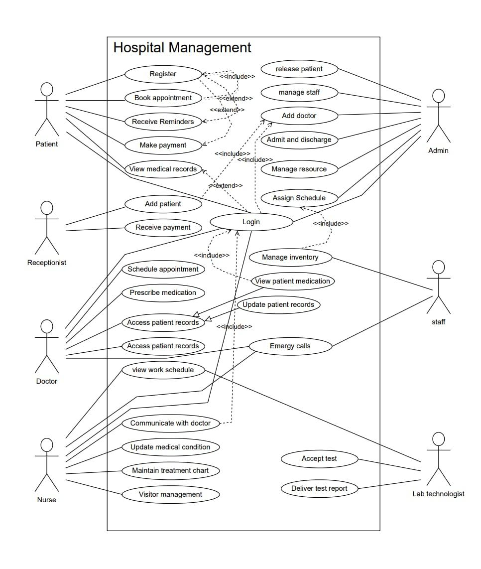

## **3.8 Sequence Diagram (patient)**

## **3.9 Sequence Diagram (Admin)**

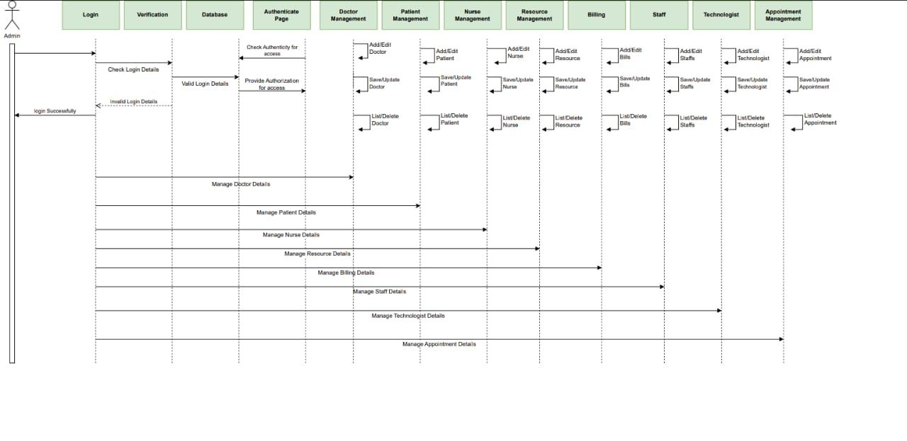

## **3.10 Sequence Diagram (Doctor)**

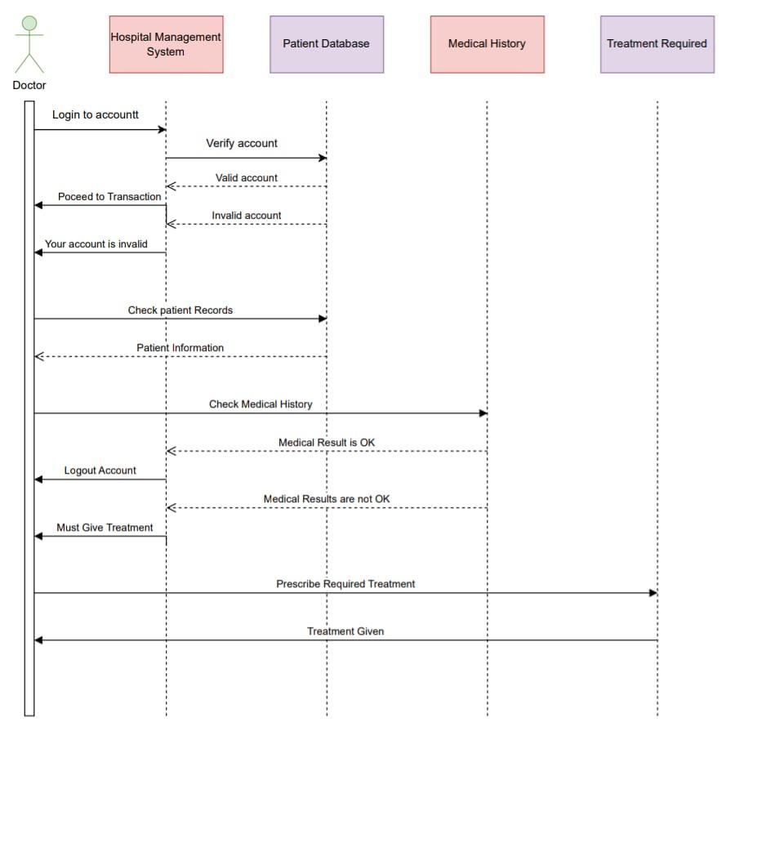

# **4. Data Requirements**

## **4.1 Medical Records**: The system should maintain electronic health records (EHR) containing details of a patient's diagnoses, treatments, medications, laboratory results, radiology reports, and other medical information.

## **4.2 Personal Information**: The system should capture and store patient, doctor, administrators’ data such as name, age, gender, contact information, medical history, and any relevant personal details.

## **4.3 Appointments and Scheduling**: The system should manage appointments and scheduling for patients, doctors, nurses, and other staff members. This includes recording appointment details, availability of healthcare professionals, and facilitating appointment booking and rescheduling.

## **4.4 Billing and Financial Information**: The system should handle billing and financial aspects of the hospital, including patient billing information, insurance details, payment records, and invoicing.

## **4.5 Inventory Management**: If the hospital manages its inventory internally, the system should track and manage inventory items such as medical supplies, equipment, medications, and their availability.

## **4.6 Staff and User Management**: The system should maintain a database of staff members, including doctors, nurses, administrators, and their relevant details like names, roles, contact information, and access privileges.

## **4.7 Reporting and Analytics**: The system should provide reporting and analytics capabilities, allowing administrators to generate various reports, such as patient statistics, financial summaries, operational metrics, and performance indicators.

## **4.8 Security and Privacy**: The document should specify the security and privacy requirements for protecting patient data.

## **4.9 Data Backup and Recovery**: The system should have provisions for regular data backups and a plan for data recovery in case of system failures or disasters.

## **4.10 Patient Class Diagram**:

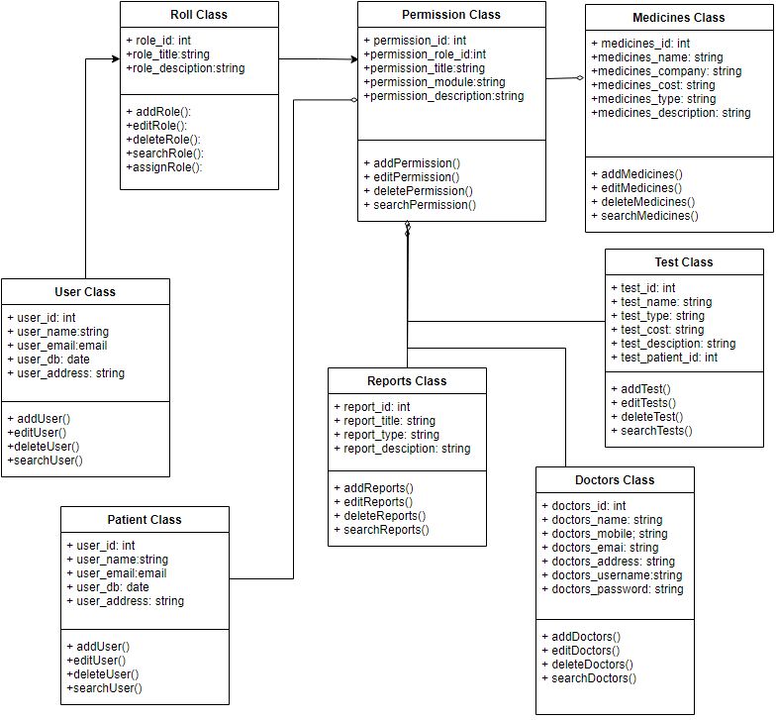

## **4.11 Hospital Class Diagram**:

## 

# **5. External Requirements**

## **5.1 Hospital Class Diagram**:**Laboratory Information Systems (LIS):** System needs to interface with a laboratory information system, it specifies the requirements for exchanging lab orders, test results, and other relevant data between the two systems.

## **5.2 Pharmacy Systems:** System outline the requirements for managing medication orders, dispensing information, medication inventory updates, and drug-drug interaction checks.

## **5.3 Electronic Health Record (EHR) Systems:** System specifies the requirements for interoperability, including the ability to import/export patient demographics, medical history, and other relevant data.

## **5.4 Billing and Insurance Systems:** System defines the requirements for submitting claims, receiving payment information, managing insurance eligibility verification, and generating accurate financial reports.

# 

# **6. Non-Functional Requirements:**

## **6.1 Availability Requirements**

**6.1.1** - System must be available 99% of the time outside of scheduled maintenance.

## **6.2 Compatibility Requirements**

**6.2.1** System must be compatible with different operating systems, such as Windows, macOS, Linux, and mobile operating systems like iOS and Android.

**6.2.2** System must be compatible with device types, including desktop computers, laptops, tablets, and smartphones.

## **6.3 Reliability Requirements**

**6.3.1** System must install any available software updates nightly to remain up to date.

**6.3.2** System must install any available software updates nightly to remain up to date. The system must have failover mechanisms to ensure continuous functioning of the website in case of software failures.

## **6.4 Scalability Requirements**

**6.4.1** System must be able to handle a large volume of concurrent users without affecting performance or availability.

**6.4.2** System must have a caching mechanism that stores frequently accessed data and pages, reducing the load on the database and speeding up page load times.

## **6.5 Interoperability Requirements**

**6.5.1** System should be able to integrate with other existing hospital systems such as laboratory equipment, billing systems, and electronic health record (EHR) systems.

**6.5.2** The system should support industry-standard data exchange formats and protocols for seamless interoperability.

## **6.6 Security Requirements**

**6.6.1** The system should have robust security measures to protect sensitive patient data and maintain patient privacy.

**6.6.2** System should include authentication mechanisms, access controls, encryption, and audit logs to prevent unauthorized access or data breaches.

## **6.7 Performance Requirements**

**6.7.1** The system should be capable of handling a large number of concurrent users and high volumes of data without significant performance degradation.

**6.7.2** Response times should be within acceptable limits to ensure efficient user interactions.

## **6.8 Maintainability Requirements**

**6.8.1** The system should be designed in a modular and extensible manner, facilitating easy maintenance, upgrades, and bug fixes.

**6.8.2** Changes to the system should be manageable and should not disrupt the overall functionality.

# **7. Supporting Section**

## **7.1 Glossary**

* **Central Patient Database:** A database managed by the health ministry, containing the medical records of individuals nationwide.
* **Local Database:** A database specific to the hospital, storing relevant data for efficient access and operations.
* **Class Diagram:** A graphical representation illustrating the data elements and relationships within a system, typically used for high-level modeling.
* **Operating System:** System software that manages computer hardware and software resources, providing essential services for computer programs to run.
* **SQL (Structured Query Language)**: is a standard language for accessing and manipulating databases.
* **Distributed Database:** A database distributed across multiple locations or networks, comprising multiple files stored in different sites
* **Front-end:** The user-facing layer of software that encompasses the design and functionality of the user interface.
* **Back-end:** The underlying components of a computer application or program that handle data processing and functionality inaccessible to the user.

## **7.2 References**

* IEEE Recommended Practice for Software Requirements Specification (IEEE-STD-83.50- 1998): [https://personal.utdallas.edu/~chung/RE/IEEE83.50-1993.5.pdf](https://personal.utdallas.edu/~chung/RE/IEEE830-1993.pdf)
* "Software Requirement Specification (SRS) Format" from GeeksforGeeks website: [https://www.geeksforgeeks.org/software-requirement-specification-srs- format/](https://www.geeksforgeeks.org/software-requirement-specification-srs-format/)
* "Software Requirement Specifications" from JavaTpoint website:

<https://www.javatpoint.com/software-requirement-specifications>

* Sample SRS Document for Gephi software: https://gephi.org/users/gephi_srs_document.pdf
* "A Practical Guide to Writing Software Requirements" by Ruth Malan and Dana Bredemeyer
* "Requirements Engineering: From System Goals to UML Models to Software Specifications" by Axel van Lamsweerde.
* "Writing Effective Use Cases" by Alistair Cockburn.
* "Software Requirements" by Karl Wiegers and Joy Beatty.